**Assignment-17**

**Creating storage account and connecting it through SAS URL:**

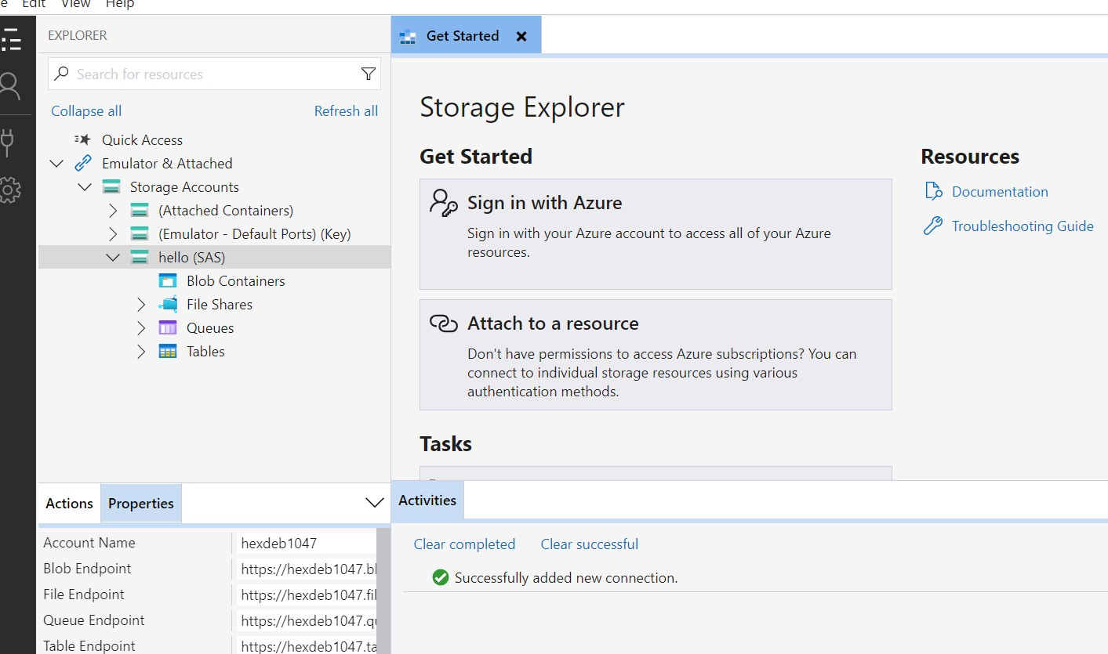

**Connection to Azure Data Lake Storage by enabling Hierarchical Namespace:**

